
24/2/2026

PPWR Transition Fund Application Process
- Starting the Application Process
To find the Application Form for the PPWR Transition Fund please go to the below link:
https://repak.ie/transition-fund
Here you will find an “Apply Now” button (below) which will navigate you to the step-by-step process further down the webpage.
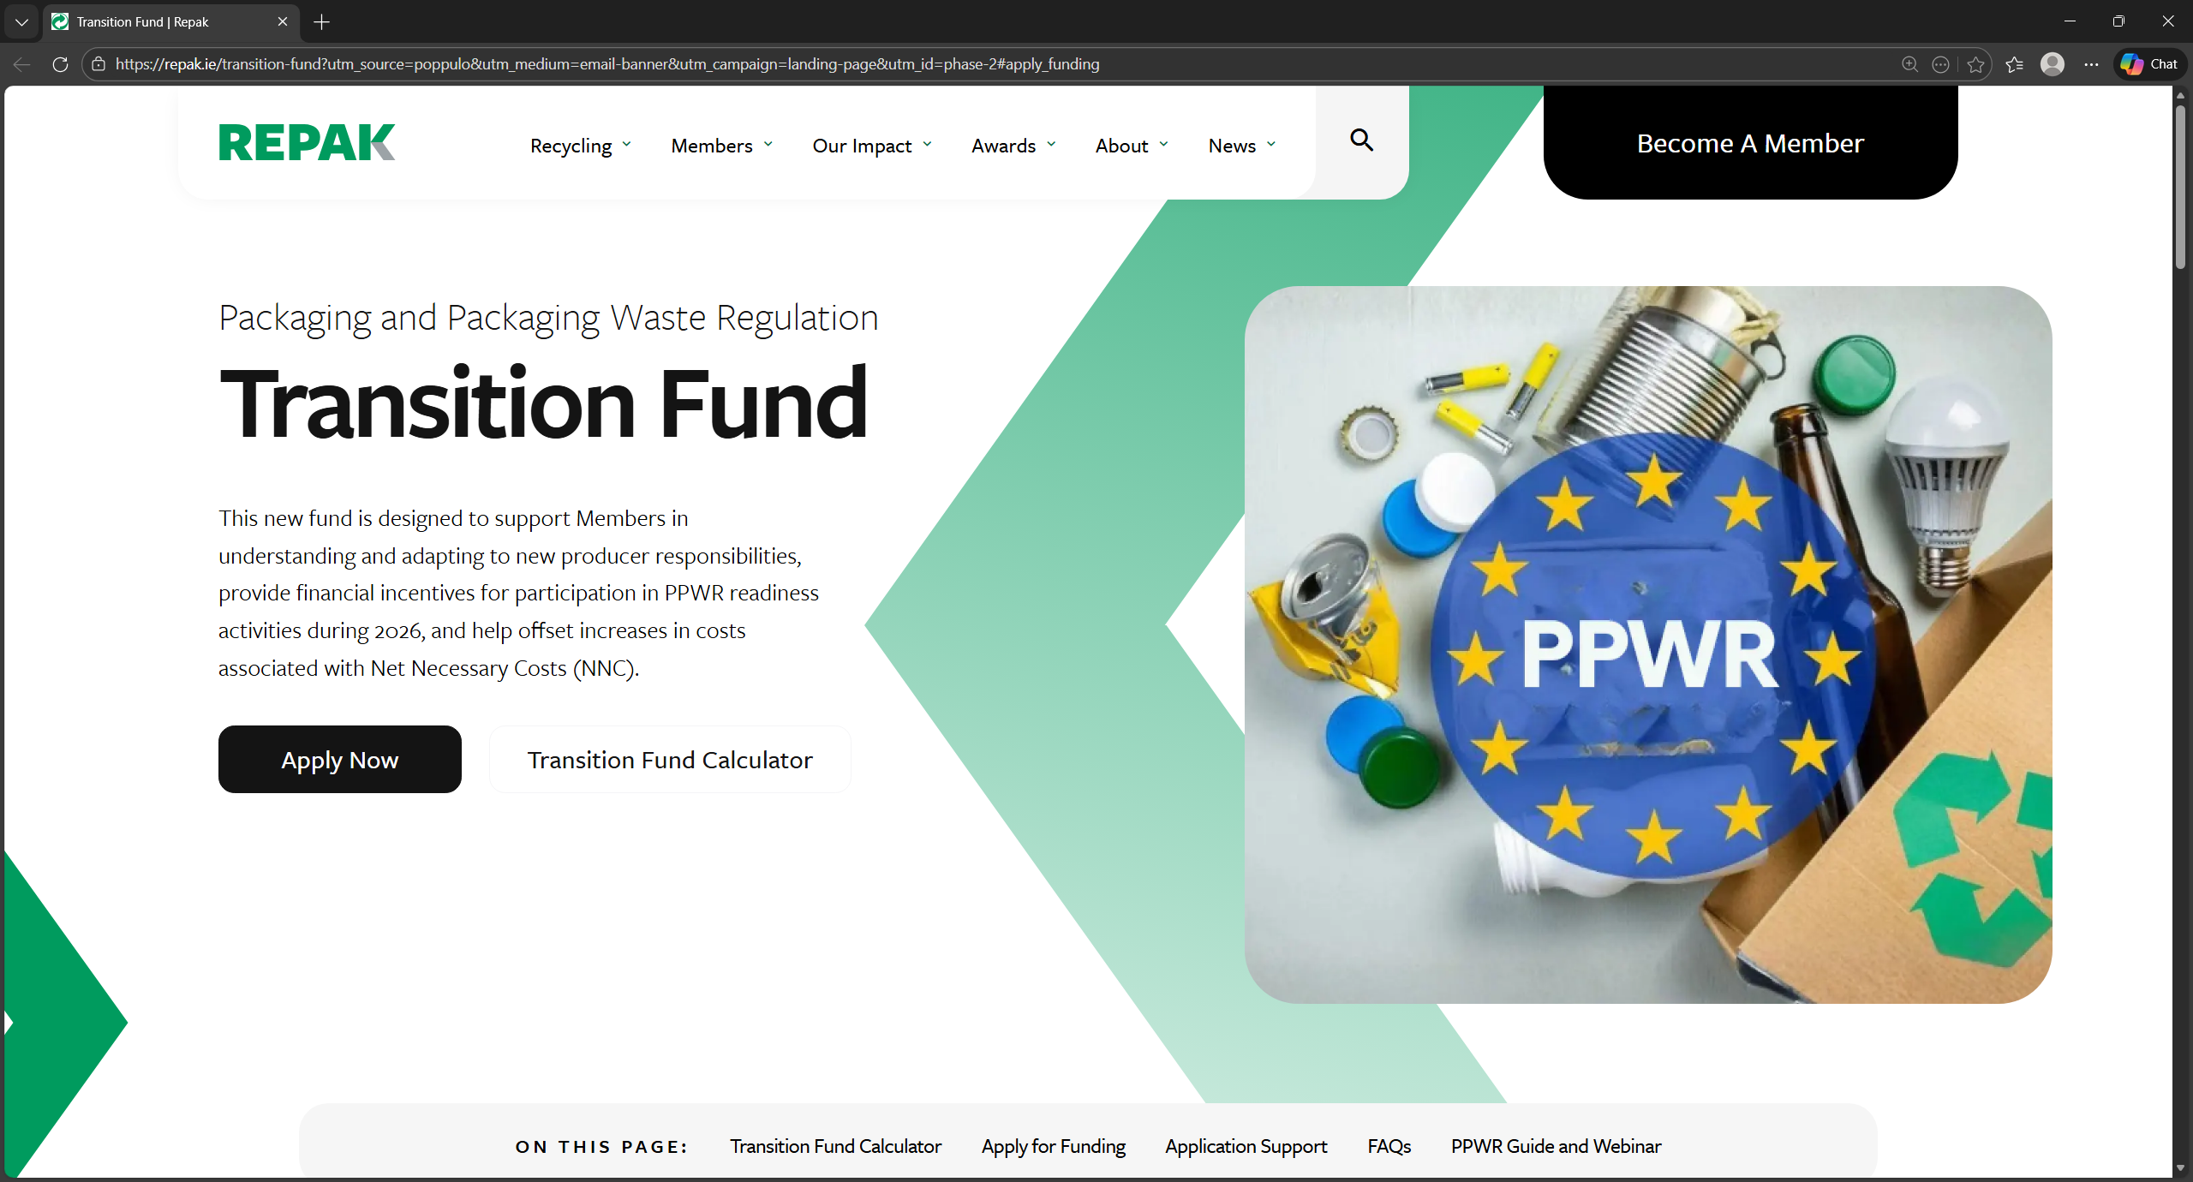
While here you will download the following files:
- Supplier Overview spreadsheet – required for each member
- Imported Goods Overview spreadsheet – only required if you submit stats in Section 1.2 of your Repak returns
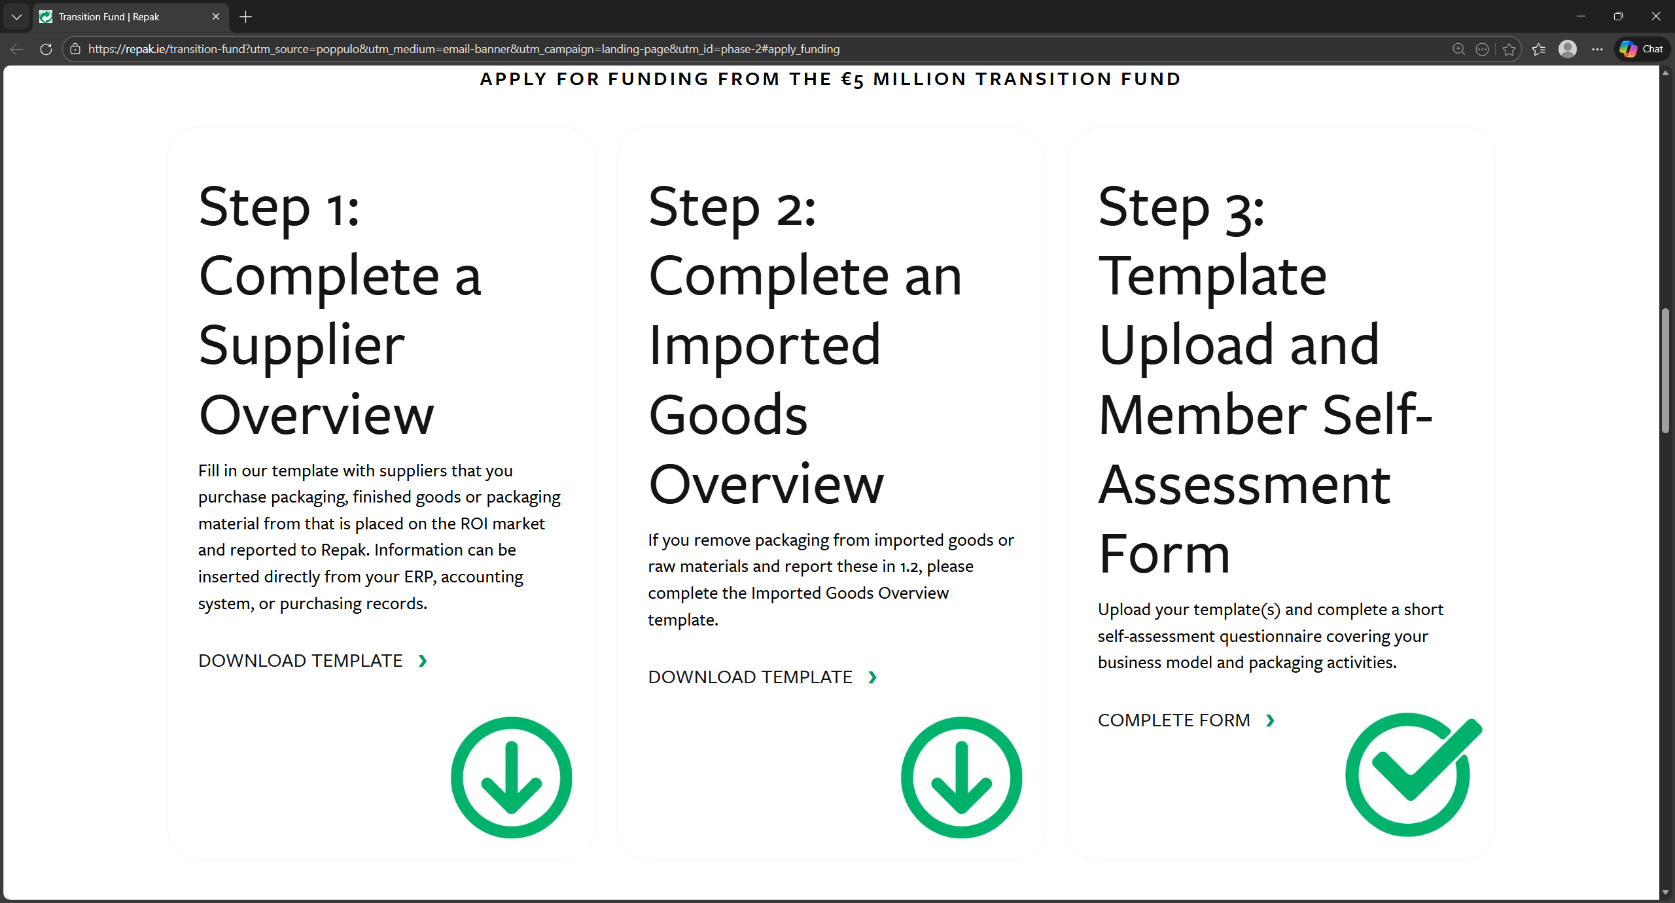
3
2
1
Next, you will open the application form which can be done by clicking link 3 in the previous image or by clicking the link below:
View link to form.
The below webpage should then open.
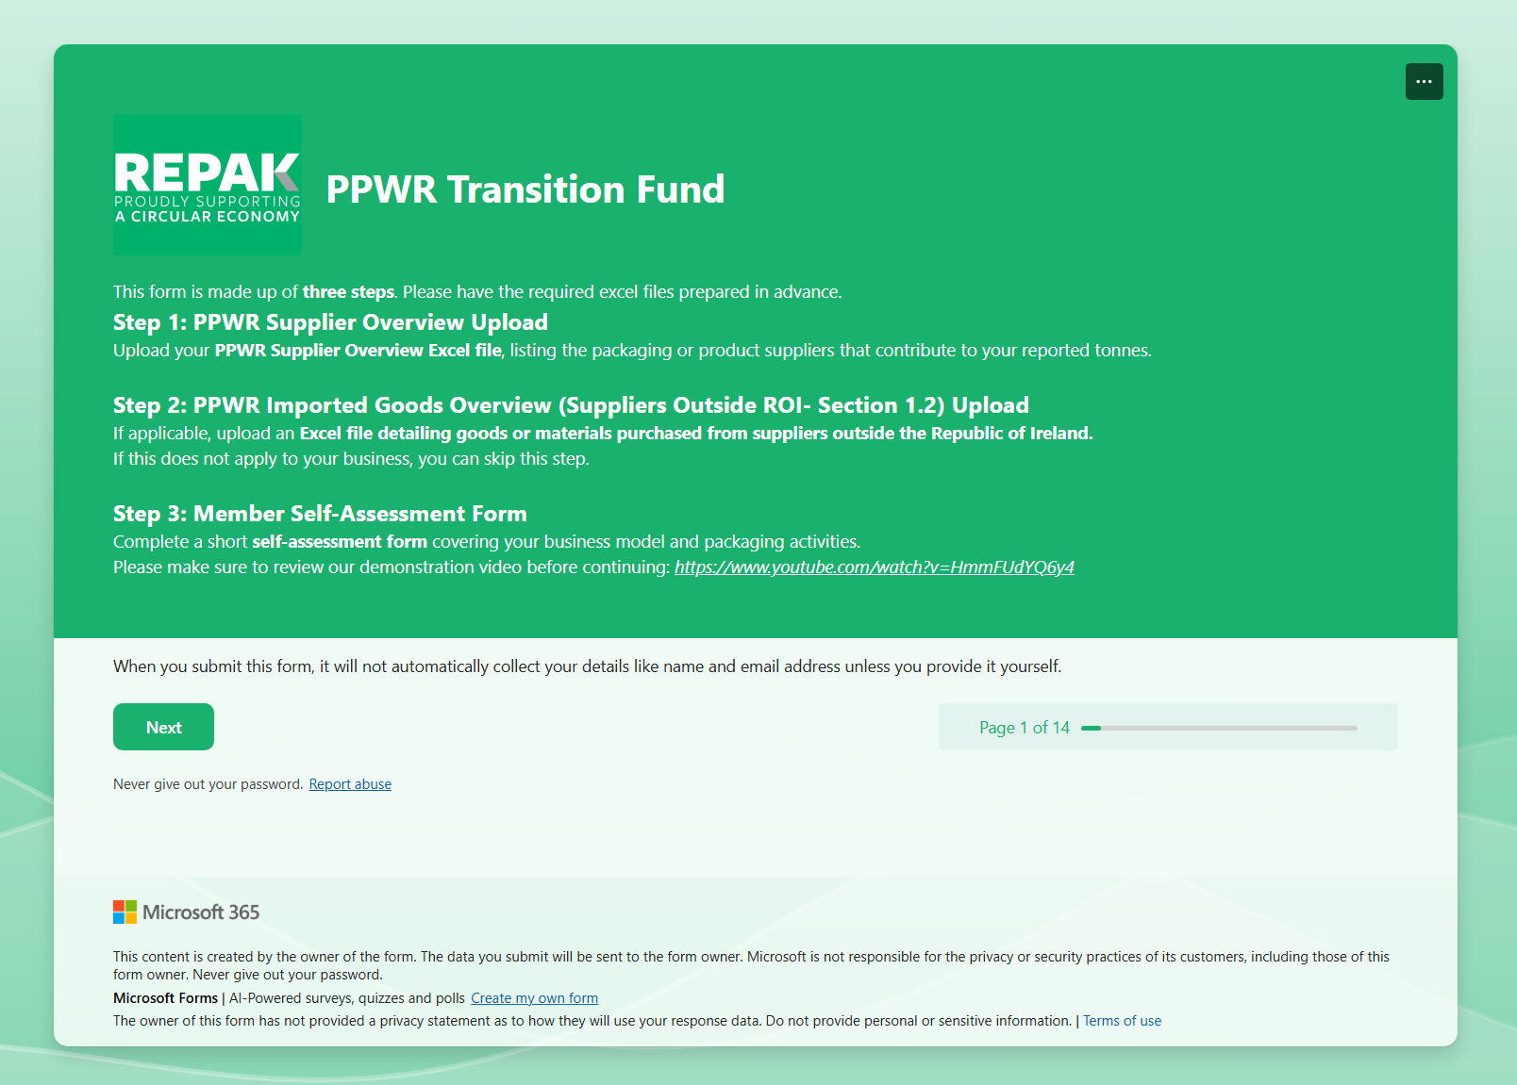
Here you will find some more information on the three steps required to complete the application.
When you’re ready click Next.

- Completing Supplier Overview Spreadsheet
The next page in the application form requires you to upload your supplier overview spreadsheet, and details how to do this.
Firstly, you will open the PPWR_Suppliers_CompanyName_MemberNumber.xlsx file which you downloaded in Section 1 of this document.
Once open you can start entering the details of your suppliers. To do this you will need the Legal Name, Trading As Name (if different), Country of Registration and VAT/Tax number. This information is typically exportable from your company’s finance/ERP system, so we suggest you contact your finance department before filling this out.
Once complete, your file should look similar to the image below. Please double check the information you have entered.
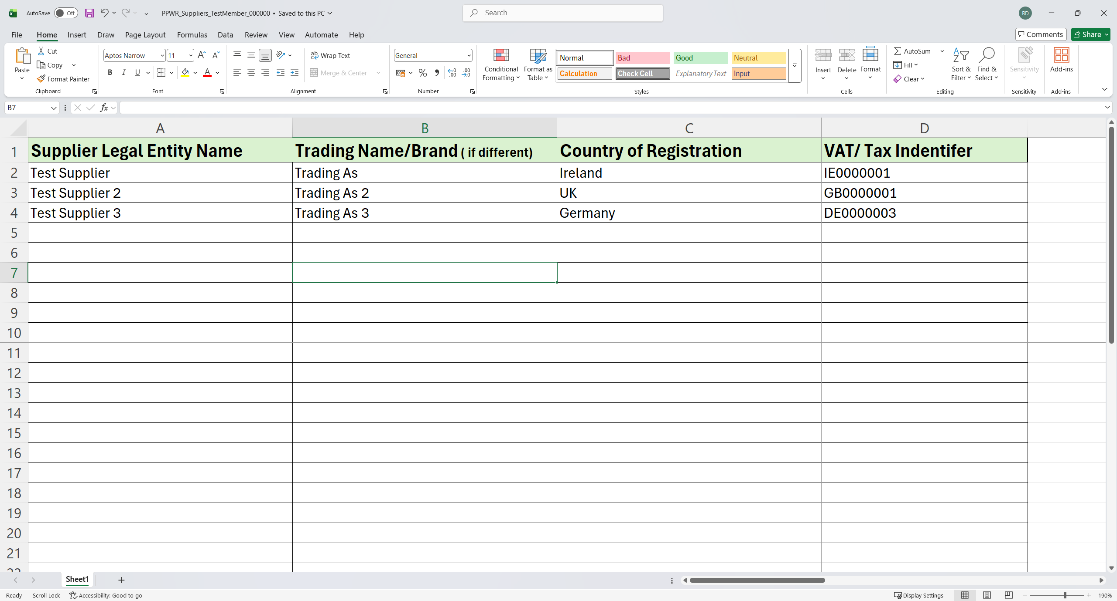
Once complete, you save the file ready for upload. It is very important that you save the file or rename the file to the following format so our systems can recognise it:
PPWR_Suppliers_CompanyName_MemberNumber.xlsx
In our example becomes:
PPWR_Suppliers_TestMember_000000.xlsx
However, you should use your Repak member name and number.
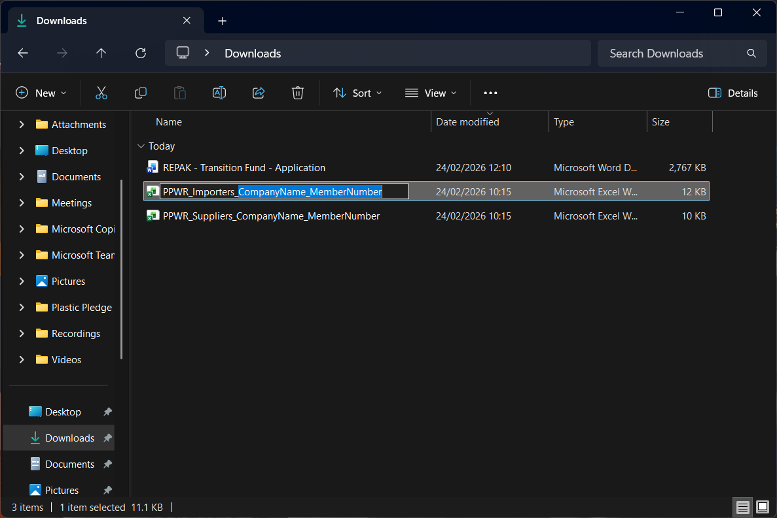
When you have saved this file in the above file name format you can return to the application form.
You are now ready to upload your supplier list. First open in the below link which is also linked in the application form page:
Application form link.
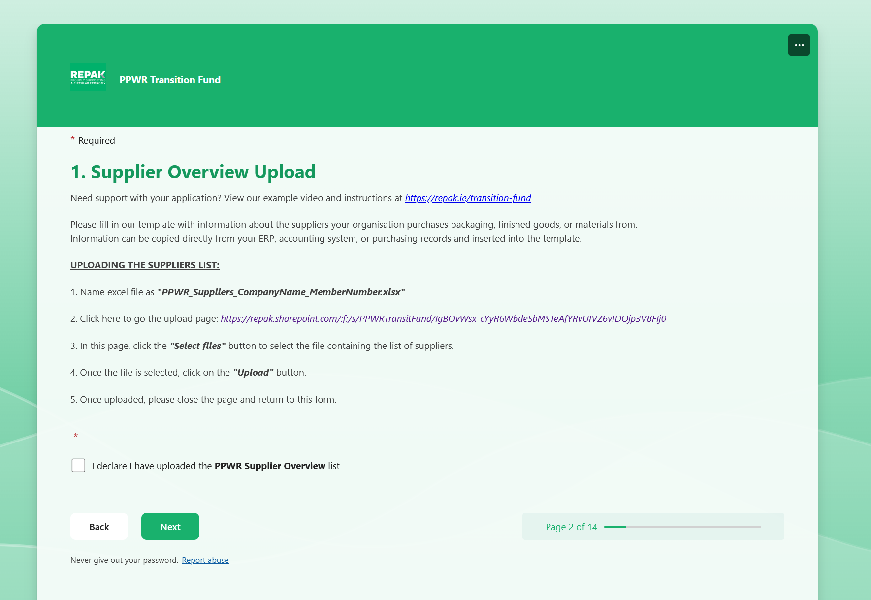
This will open the below page which asks you to upload your PPWR Supplier Overview file.
Navigate to where you have saved your file, select it, then enter your name and click Upload.
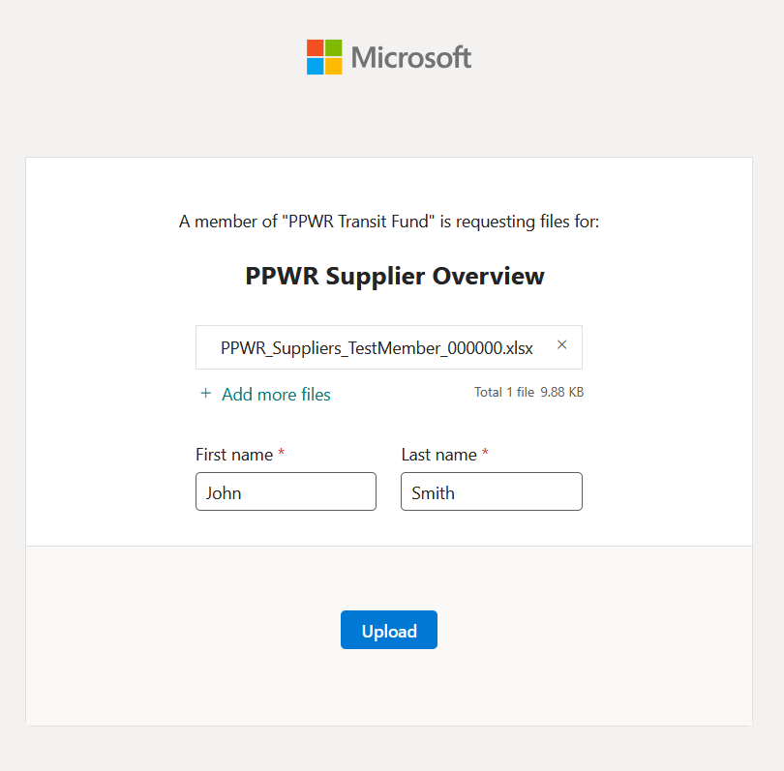
Once you have completed this you can return to the application form.
When there you can tick the box saying, “I declare I have uploaded the PPWR Supplier Overview list” and click Next to continue your application

- Completing Imported Goods Overview Spreadsheet
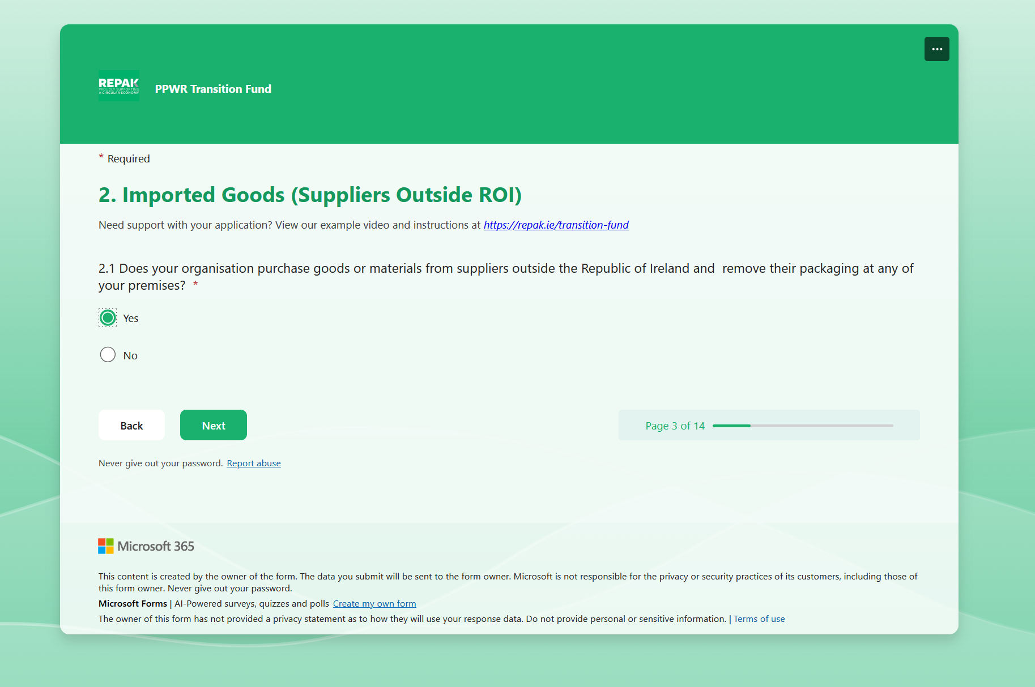
Once you have clicked next on the previous page you will be met with Step 2 of the application process which asks the following question:
“Does your organisation purchase goods or materials from suppliers outside the Republic of Ireland and remove their packaging at any of your premises?”
If you are unsure whether your company should answer yes or no to this please look at you latest Repak stats submission. If you have reported in Section 1.2 of the submission, then you must answer Yes to the above question. Otherwise please answer No, you will then be taken to step 3 of the application process (detail in chapter for this document).
If you answered yes, you will be met with a similar screen to before with the below link to upload your Imported Goods Overview sheet.
https://repak.sharepoint.com/:f:/s/PPWRTransitFund/IgDu6dUZrcrZQbNBFmATIqHWAWOCTF-Z8xQMc9YCufeO8Go
NOTE: This is not the same link as before.
Below is an example of the information required in the Imported Goods Overview spreadsheet. This is very similar to the supplier sheet but now includes a column for you to estimate the number of tonnes of packaging you remove.
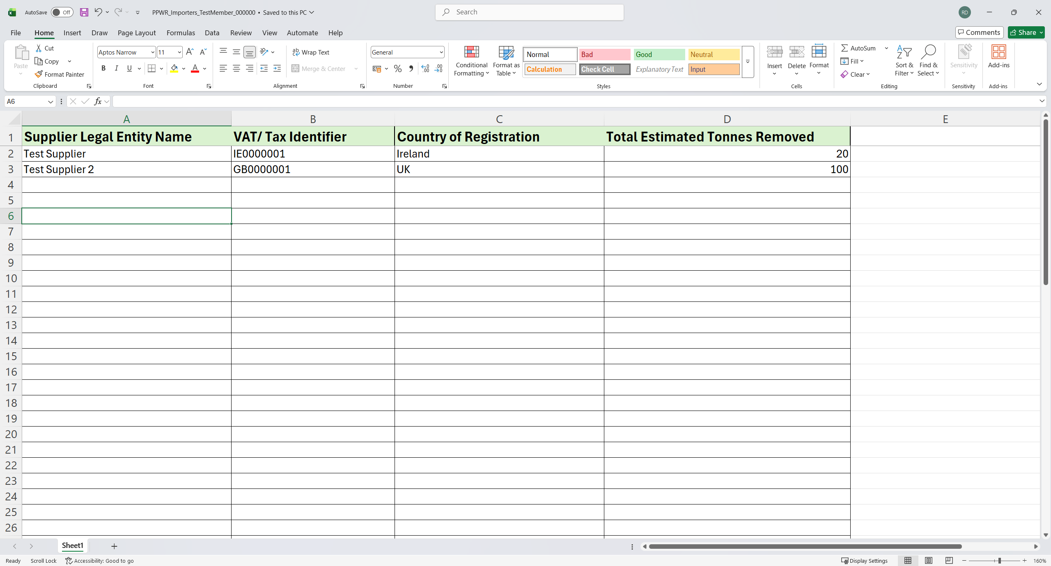
Once complete, you save the file ready for upload. Again it is very important that you save the file or rename the file to the following format so our systems can recognise it:
PPWR_Importers_CompanyName_MemberNumber.xlsx
In our example becomes:
PPWR_Importers_TestMember_000000.xlsx
When you have uploaded the file you can return to the application, tick the box saying, “I declare I have uploaded the PPWR Importer Goods Overview list” and click Next.
Please see the images on the next page for reference.

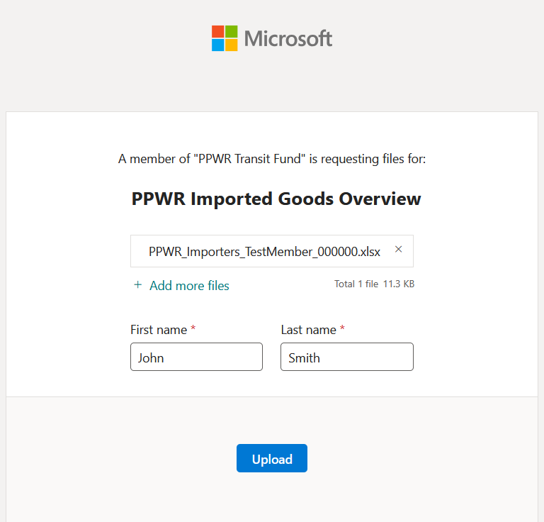
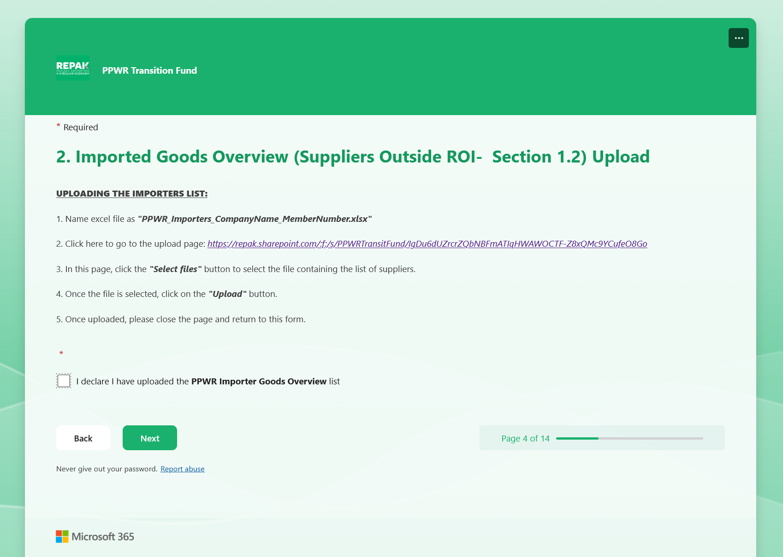

- Completing the Self-Assessment Form
When you have uploaded both files (where applicable) and moved through the application form you will be met with the below screen. This is the start of the self-assessment section of the form.
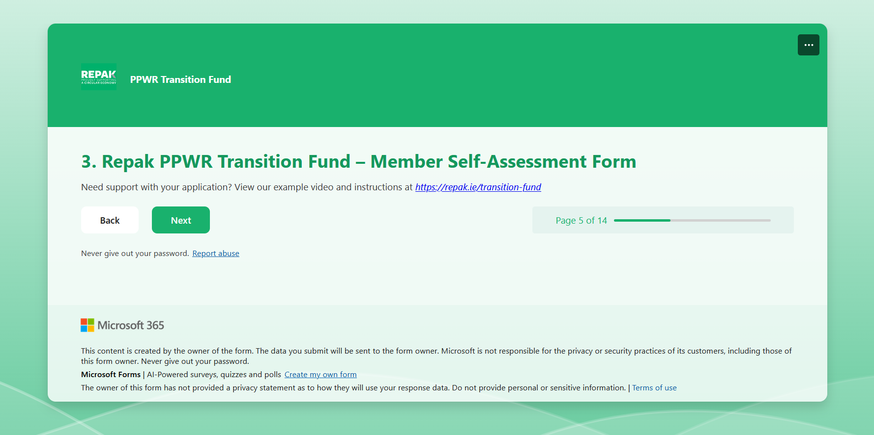
The first page “3.1 Member Details” is to be filled out using your company details, your own details and the contact details of your PPWR contact person. Once complete you can move to the next page.
NOTE: Any zeros in front of your account number, CRO number or phone number will be removed from the form. This is completely normal.
In the final part of this page, we ask that you login to your Repak portal account and confirm that the IBAN you have entered is correct, as without this you will not be able to receive the PPWR Transition Fund payment.

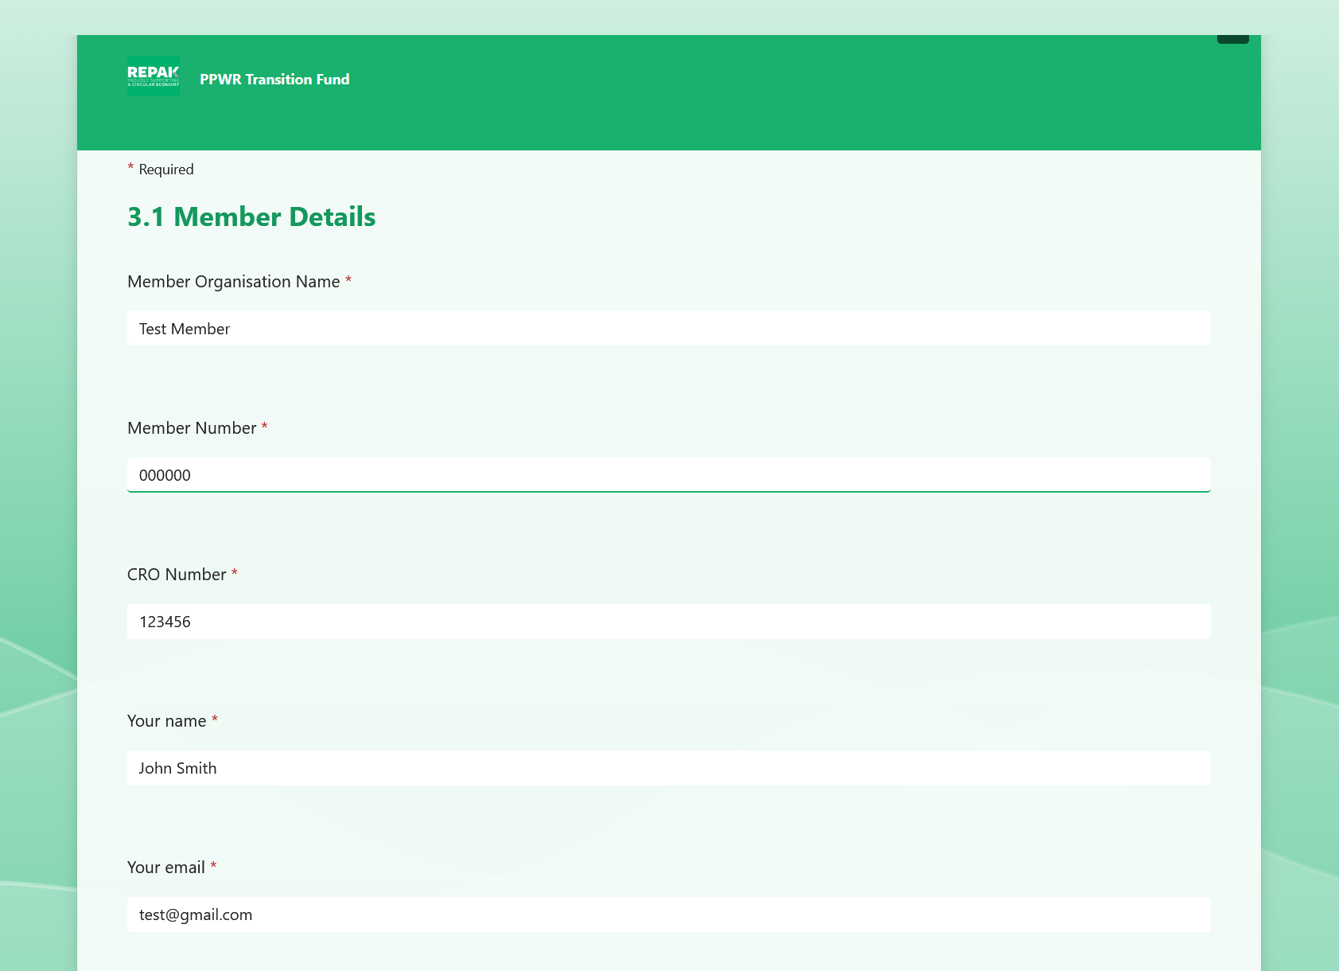
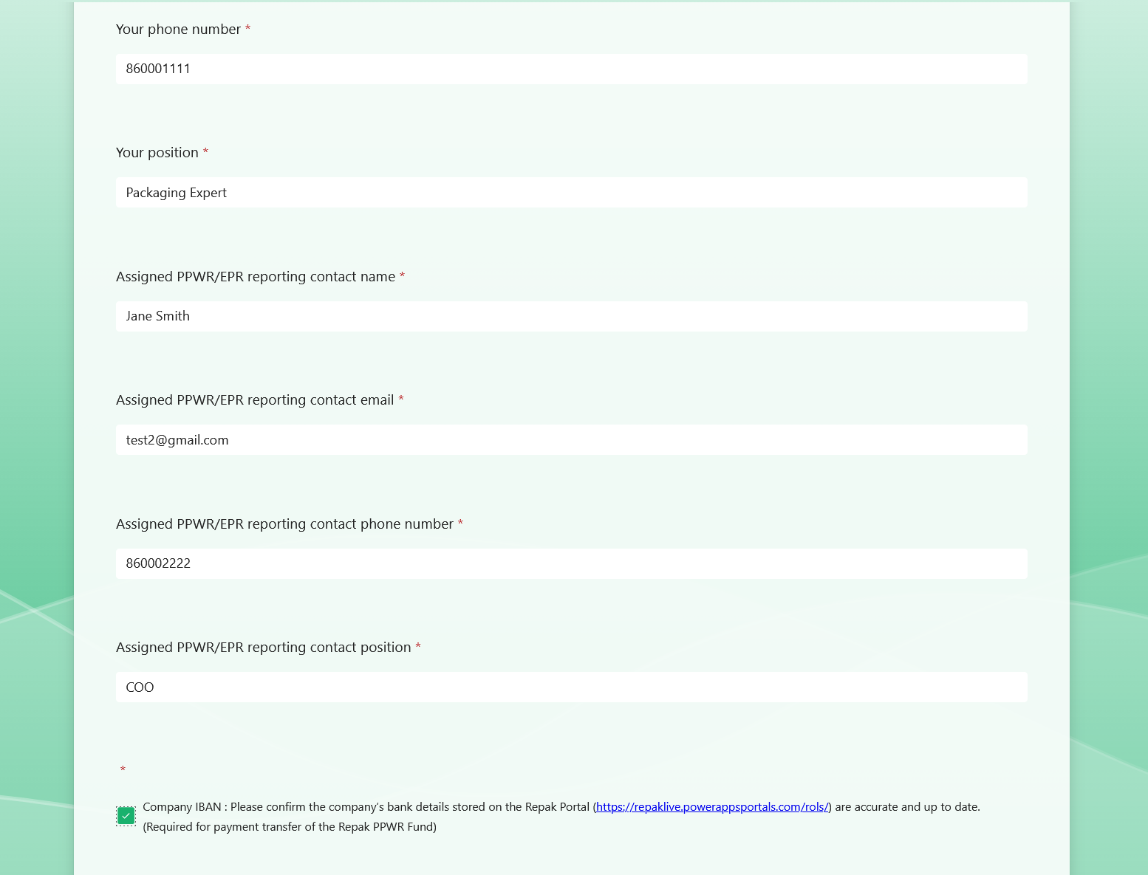

The next page shows the additional qualifying criteria for the PPWR Transition Fund, detailed below.
- Read the PPWR guide linked at https://repak.ie/images/uploads/downloads/Summary_of_EU_PPWR_February_2025_1.pdf
- Attend a PPWR information webinar. Registration details will be shared in due course.
Once you have completed these, please click the marked box and continue the application.
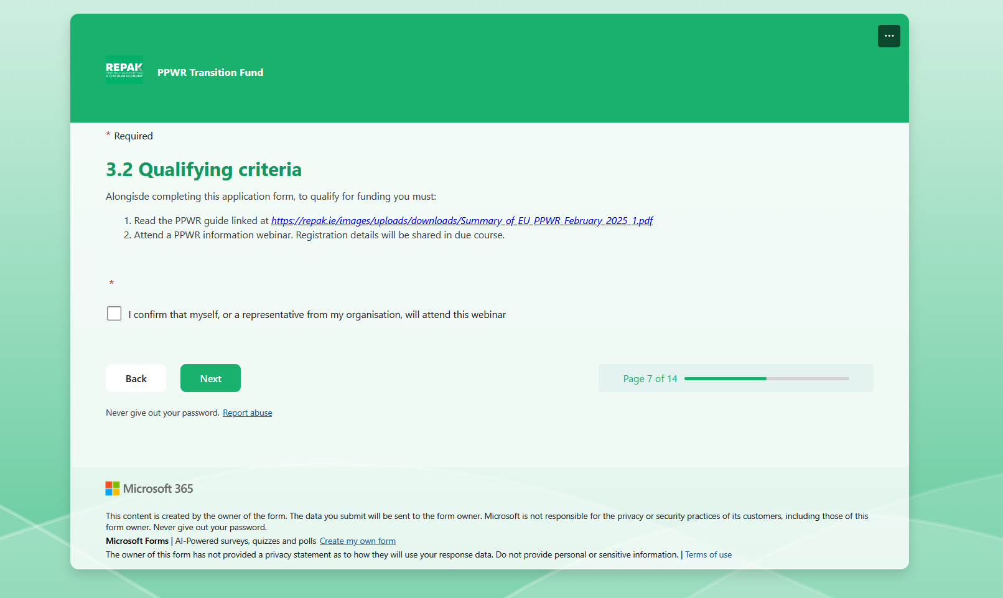

The next section relates to consultants – if your company does not use a consultant to complete you packaging returns then you can click No in this section and continue.
However, if you do, we ask that you tell us which consultant you use and when you are planning to review your data with your consultant considering the introduction of PPWR.
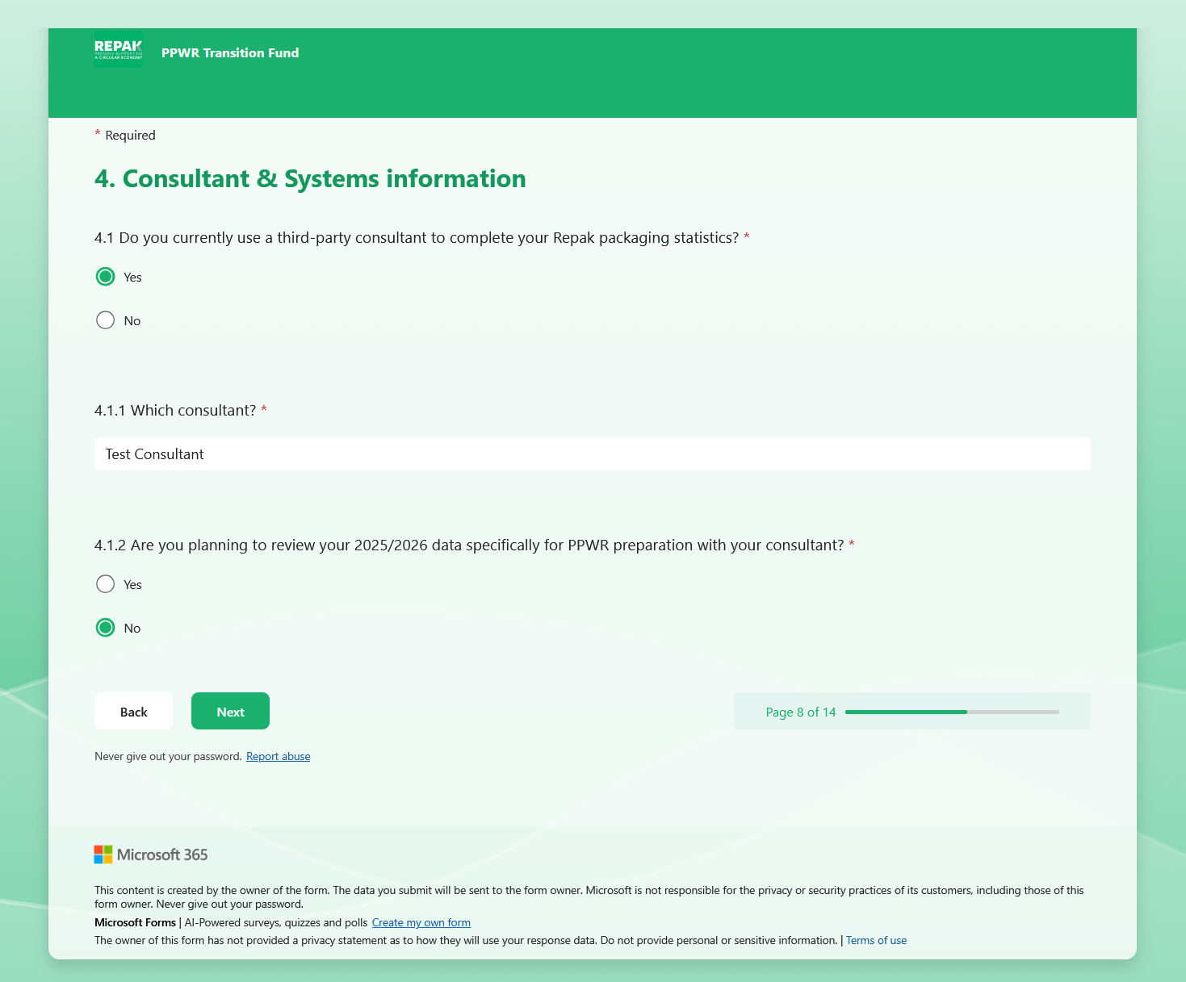

Similarly, the next relates to your ERP or compliance system. We would like to know whether your internal systems are set up to accommodate the PPWR requirements. If so, please let us know what system(s) you are using in the box provided.
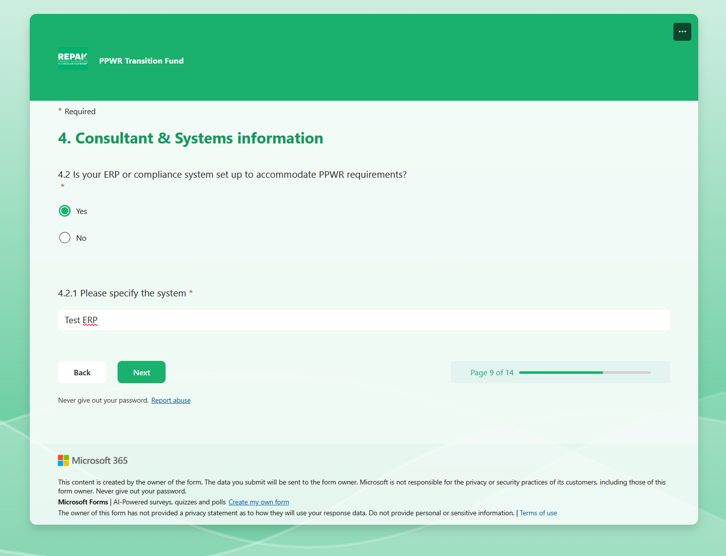
The final section of the application focuses on how Repak can best support your organisation going forward.
We would appreciate your input on whether you would be interested in participating in a PPWR pilot programme, whether your organisation requires specific training on the new PPWR material categories, and what additional supports may be needed.
This section also provides an opportunity to share any further feedback or comments that have not already been addressed in the application form.

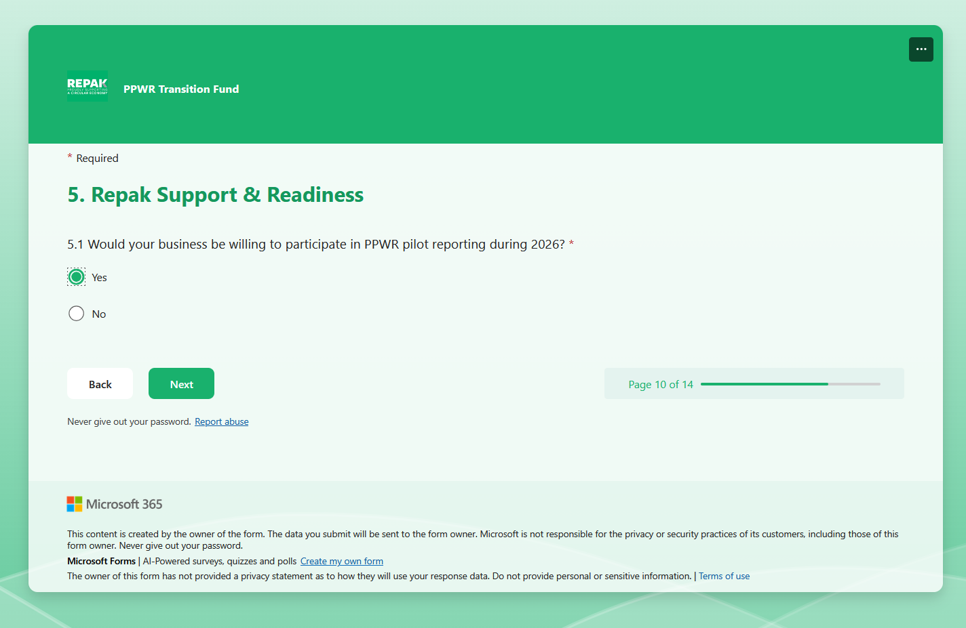

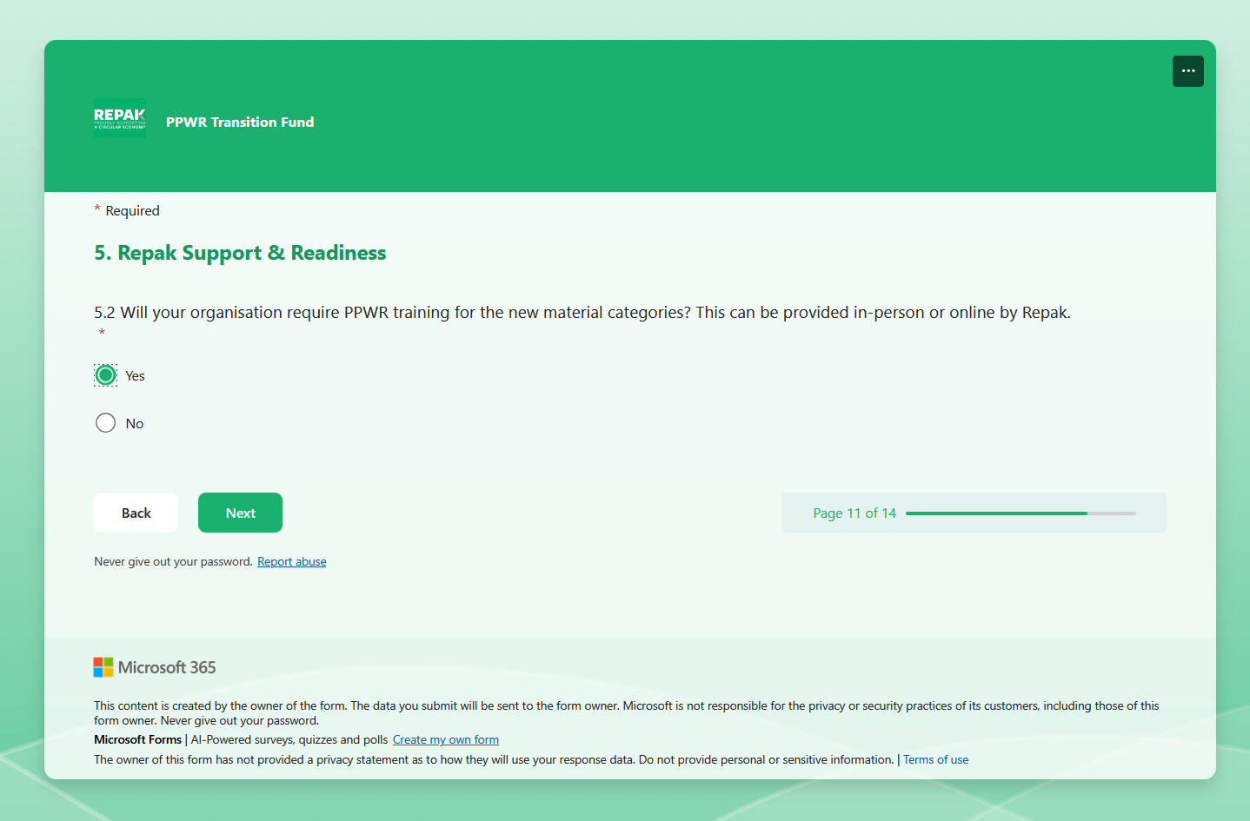

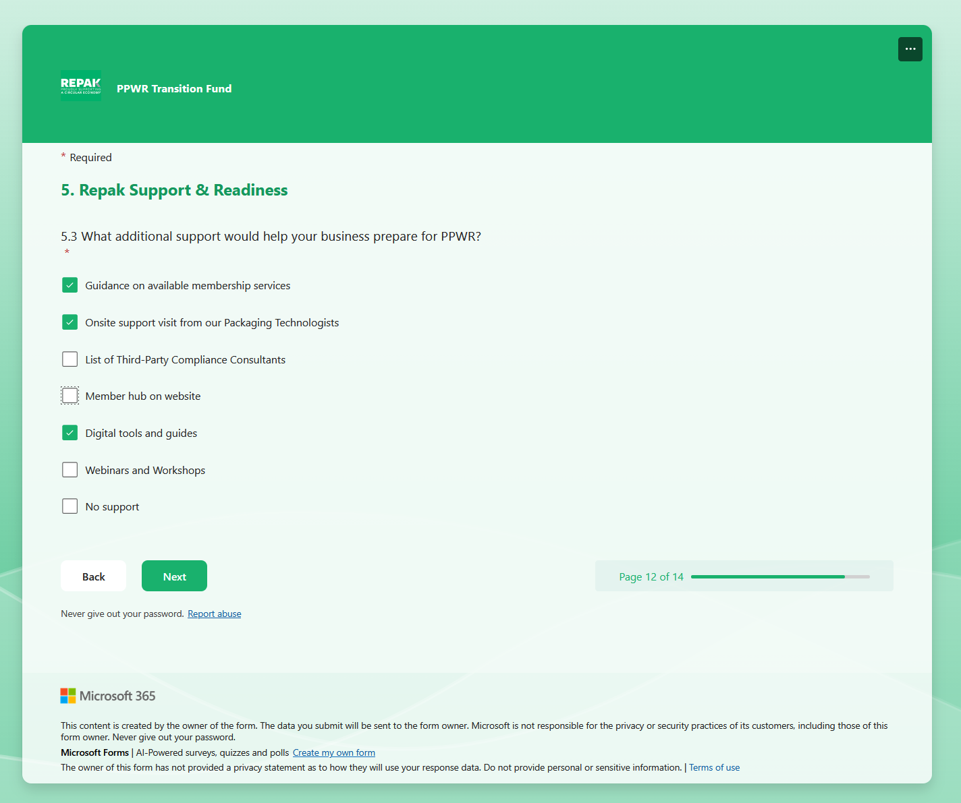
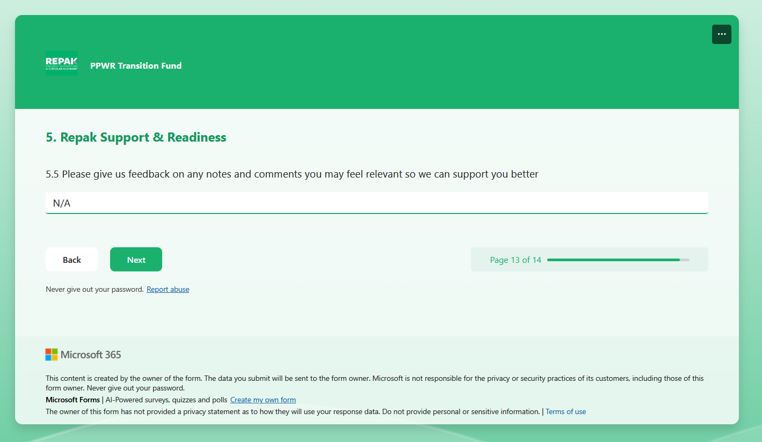
Lastly we ask you to complete the below declaration which states that you have uploaded the Supplier and Imported Goods (if applicable) Overview spreadsheets and completed the Self-Assessment form fully.
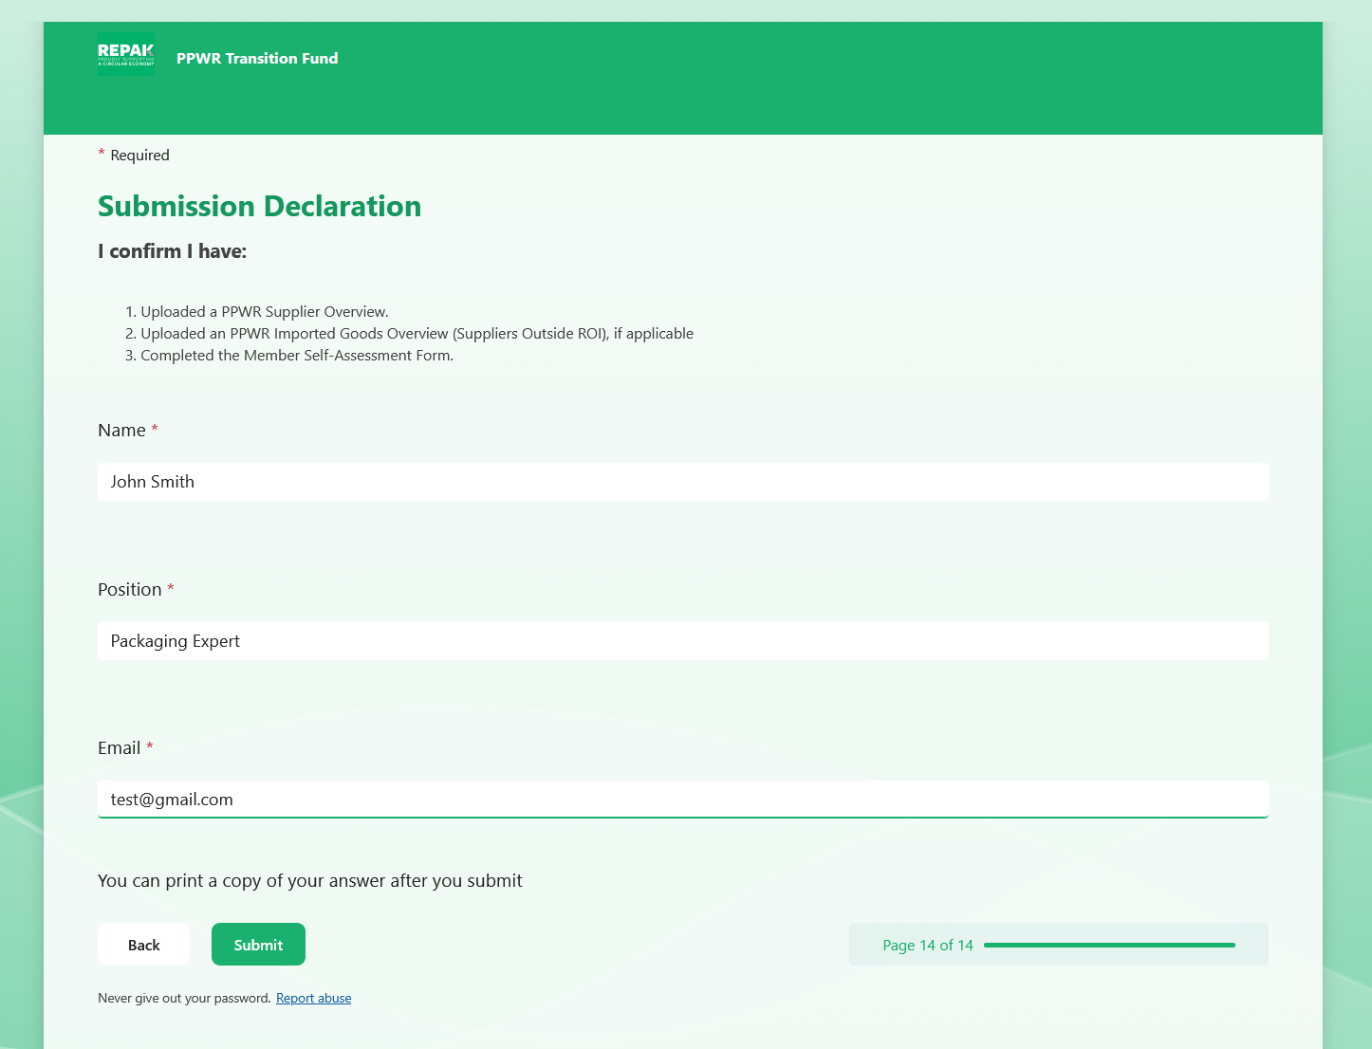
Once the declaration is complete you will see the below message to confirm you have successfully submitted your PPWR Transition Fund application form. If you have any issue please contact us at Membership@Repak.ie.
